# Creating static ancillary for GA7.0 for BARRA2 and BARPA

## Suite

It is based on u-ac280, which is documented in [GAAncils/GA7.0/GeneratingAncils – Global Atmosphere (metoffice.gov.uk)](https://code.metoffice.gov.uk/trac/GA/wiki/GAAncils/GA7.0/GeneratingAncils)

We copied the suite and developed as [u-ch954](https://code.metoffice.gov.uk/trac/roses-u/browser/c/h/9/5/4/trunk) at NCI.

Note that I cannot find the specific ancillary suite for PS44.

## Changes made to the suite

* Porting to run on NCI and using local CAP9.1 build and use access module ants/0.10.0 build
* Modified the ancilOrog to use $ANCIL_MASTER/orography/GLOBE30/v1/GLOBE30_aus.orog
* Modified the ancilOrog to remove isolated negative orography points, using l_remove_neg_pt=.true.
* Allowed the suite to create ancillary for LAM with prescribed horizontal grid definition in etc/grid.*
* Increase the search radius for ancilSoiltemp, otherwise we get the "ERROR SEARCH RADIUS BEYOND GRID"
* Added the ancilGeneralMurk app, which was missing, back in from u-ac281 (GA7 ancil suite for N1280).
* Revert to use the global master file for Ozone ancillary as the required file is unavailable and is likely relevant for our region.
* Added an opt configuration to create smoothed/filtered orography in ancilOrog app.
* Added the option to create more accurate land sea mask from CCI – see **Section 7 and 8**. This is triggered by using CCI_MASK=true in rose-suite.conf.
* Add the option to create GL9 CCI-based vegetation fraction ancillary, LAI and lidar-derived canopy height (veg.func) ancillary – **Section 8**.

Note that tasks ukca_package_build, and move_files_hpc are not ported and not used.

## Offline (out-of-suite) manipulation to the ancillary

* ~~Used ancil_simardCanHT.py to generate new canopy height ancillary in ./vegetation/func_type_simard/qrparm.veg.func~~ No longer needed since the suite u-ch954 can generate GL9 vegfunc ancillary. See Section 8 for comparison between canopy height generated by this script and by the suite.
* Used change_pole_long.py to change the header information pole_long from 0 to 180. And use mule to modify fixed_length_header.horiz_grid_type = 103, field[n].lbcode = 101
* Used bin/correct_orog_barra2hres.sh to merge standard and smoothed orography over north of 10S.

## Differences from the current set of BARRA-R2 ancillary rougcreated for the development

Differences between /g/data/du7/barra2/data/ancil_0p11_v3 and /g/data/du7/barra2/data/ancil_0p11_v2 (this is the current set, created using u-bk244, BARPA ancillary suite).

Land sea mask (33). No systematic difference, minor differences around coast.

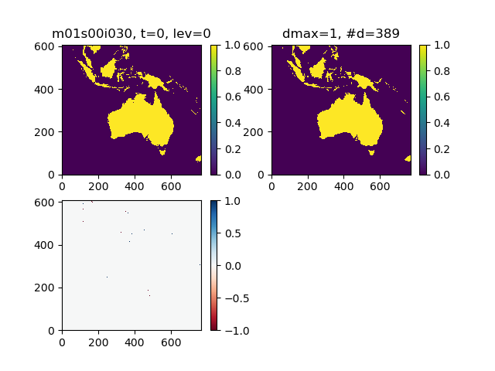

Orography (33): No Systematic difference, isolated differences around coasts.

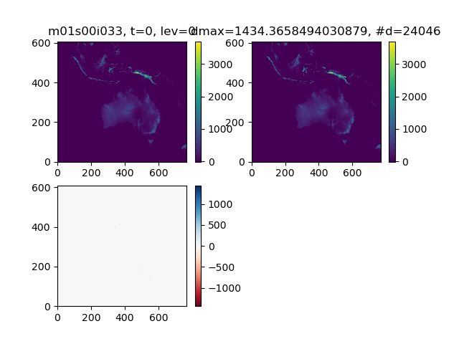

Tree fraction (216): Identical

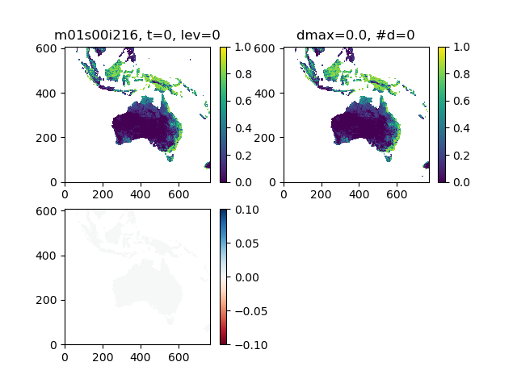

## Final BARRA-R2 domain

To include the whole of CORDEX-Australasia domain,

The red lines trace the [Region 9: Australasia – Cordex](https://cordex.org/domains/region-9-australasia/)

The dashed box removes the buffer zone (18 cells from the edge the boundary).

The below GRID definition ensures that, excluding the buffer zone, the CORDEX domain is included.

The grid definition,

/home/548/chs548/roses/u-ch954/etc/grid.barra-r2 reads,

&GRID

POINTS_LAMBDA_TARG=1104,POINTS_PHI_TARG=624,

LAMBDA_ORIGIN_TARG=87.27,PHI_ORIGIN_TARG=-54.34,

INWSW=1,DELTA_LAMBDA_TARG=0.11,DELTA_PHI_TARG=0.11,

PHI_POLE=90.0,LAMBDA_POLE=180.0,ROTATED=F,

GLOBAL=F

/

This has the lat and lon range between 87.27 to 208.6, and -54.34 to 14.19deg.

For BARPA-R, which is 17km in resolution, I define the grid.barpa-r:

&GRID

POINTS_LAMBDA_TARG=788,POINTS_PHI_TARG=446,

LAMBDA_ORIGIN_TARG=87.27,PHI_ORIGIN_TARG=-54.34,

INWSW=1,DELTA_LAMBDA_TARG=0.1545,DELTA_PHI_TARG=0.1545,

PHI_POLE=90.0,LAMBDA_POLE=180.0,ROTATED=F,

GLOBAL=F

## Domain of the ensembles

I consider two possible resolutions for BARRA-RE2: 0.22deg and 0.33deg.

For 0.22deg:

&GRID

POINTS_LAMBDA_TARG=550,POINTS_PHI_TARG=310,

LAMBDA_ORIGIN_TARG=87.38,PHI_ORIGIN_TARG=-54.12,

INWSW=1,DELTA_LAMBDA_TARG=0.22,DELTA_PHI_TARG=0.22,

PHI_POLE=90.0,LAMBDA_POLE=180.0,ROTATED=F,

GLOBAL=F

For 0.33deg:

&GRID

POINTS_LAMBDA_TARG=368,POINTS_PHI_TARG=208,

LAMBDA_ORIGIN_TARG=87.435,PHI_ORIGIN_TARG=-54.175,

INWSW=1,DELTA_LAMBDA_TARG=0.33,DELTA_PHI_TARG=0.33,

PHI_POLE=90.0,LAMBDA_POLE=180.0,ROTATED=F,

GLOBAL=F

|  |  |  |  |  |  |
| --- | --- | --- | --- | --- | --- |
| **Domain** | **Delta in deg** | **lonmin** | **lonmax** | **latmin** | **latmax** |
| ~~BARRA-R2~~ | ~~0.11~~ | ~~87.270~~ | ~~208.600~~ | ~~-54.340~~ | ~~14.190~~ |
| ~~BARRA-RE2 option 1~~ | ~~0.22~~ | ~~87.380~~ | ~~208.160~~ | ~~-54.120~~ | ~~13.860~~ |
| ~~BARRA-RE2 option 2~~ | ~~0.33~~ | ~~87.435~~ | ~~208.545~~ | ~~-54.175~~ | ~~14.135~~ |
| BARPA-R | 0.1545 | 86.336 | 209.4725 | -55.275 | 15.3315 |

## Revisions to the BARRA-R2 grid

The Var grid set up for the BARRA-R2 grid described in Section 6, led to move Var failure as described in [#885 (VAR crash after changing to new LAM LS grid) – VAR (metoffice.gov.uk)](https://code.metoffice.gov.uk/trac/var/ticket/885#comment:2) . The possible fix is to change the aspect ratio of the Var grid, and thus changing the full-res model grid as well.

Making this change to consider the following:

&GRID

POINTS_LAMBDA_TARG=1104,POINTS_PHI_TARG=668,

LAMBDA_ORIGIN_TARG=87.27,PHI_ORIGIN_TARG=-59.18,

INWSW=1,DELTA_LAMBDA_TARG=0.11,DELTA_PHI_TARG=0.11,

PHI_POLE=90.0,LAMBDA_POLE=180.0,ROTATED=F,

GLOBAL=F

/

This has the lat and lon range between 87.27 to 208.6, and -56.34 to 14.19deg.

Changes are also made for the ensemble grids for 0.22 and 0.33deg:

&GRID

POINTS_LAMBDA_TARG=550,POINTS_PHI_TARG=332,

LAMBDA_ORIGIN_TARG=87.55,PHI_ORIGIN_TARG=-58.91, INWSW=1,DELTA_LAMBDA_TARG=0.22,DELTA_PHI_TARG=0.22,

PHI_POLE=90.0,LAMBDA_POLE=180.0,ROTATED=F,

GLOBAL=F

/

&GRID

POINTS_LAMBDA_TARG=366,POINTS_PHI_TARG=220,

LAMBDA_ORIGIN_TARG=87.71,PHI_ORIGIN_TARG=-58.74, INWSW=1,DELTA_LAMBDA_TARG=0.33,DELTA_PHI_TARG=0.33,

PHI_POLE=90.0,LAMBDA_POLE=180.0,ROTATED=F,

GLOBAL=F

/

## Land sea mask

There are appreciable differences between IGBP-based and CCI-based land sea mask. This is shown below where the two land sea masks produced by the Nested Suite are compared.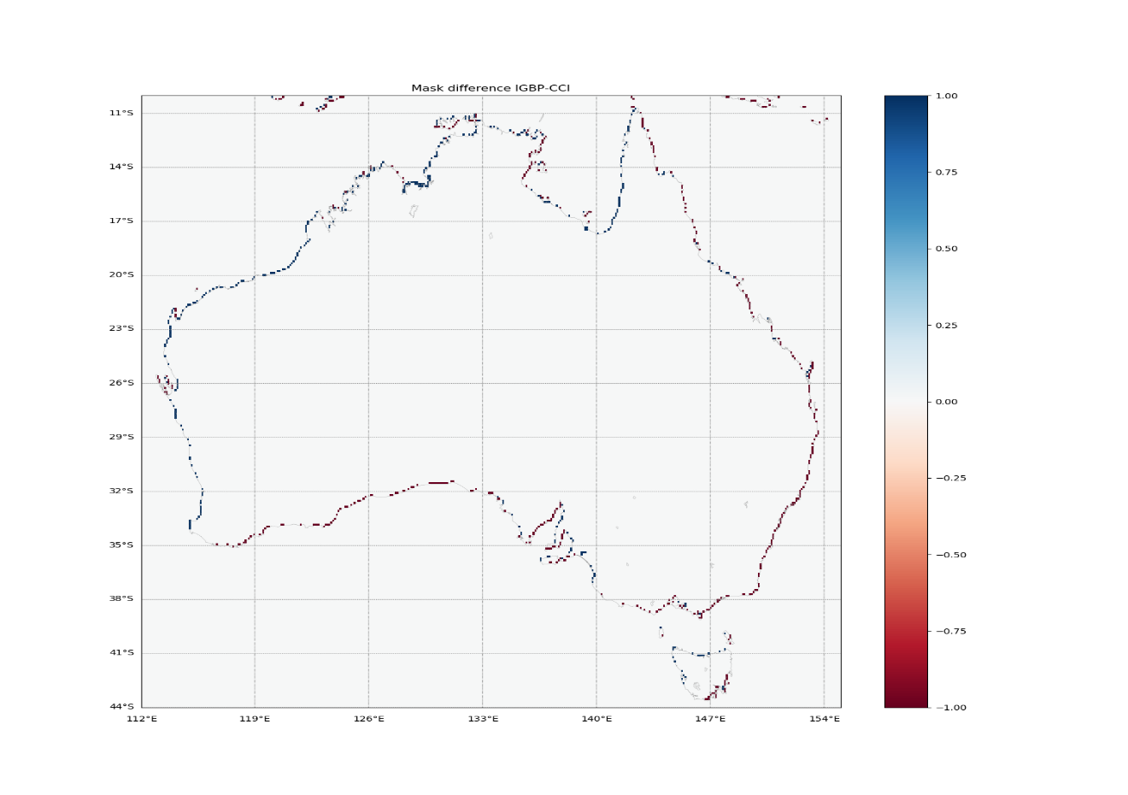 CCI-based land sea mask should be more accurate. IGBP has offset issue that varies at different regions.

The land sea masks are checked against GA's DLCDv2 data set at locations (going down the list, Hobart, Melbourne, Adelaide, Sydney, Brisbane, Townsville, Lake Eyre, Lake Torrens). It is quite obvious that the CCI-based land mask (left column) is showing better agreement with DLCD than IGBP-based mask (right column).

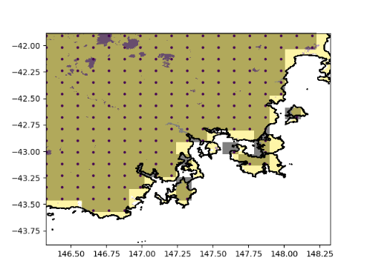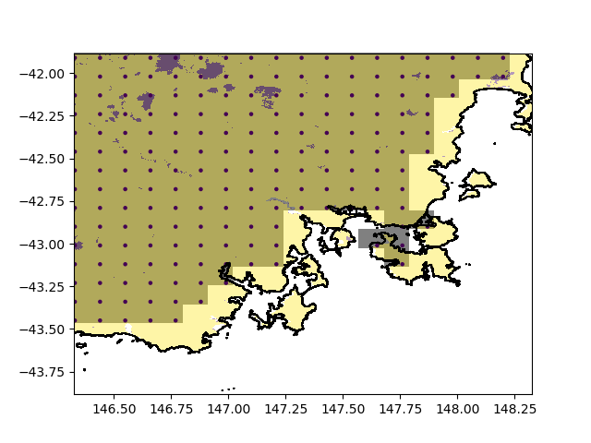

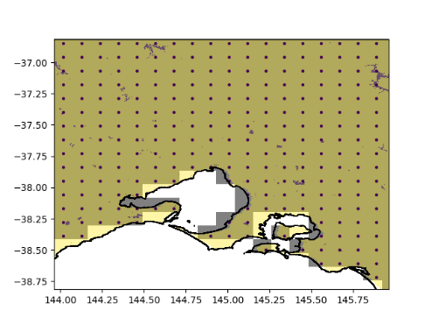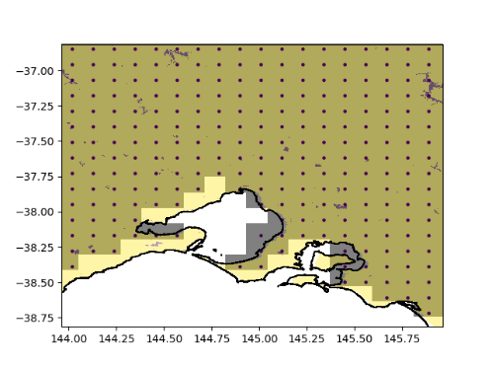

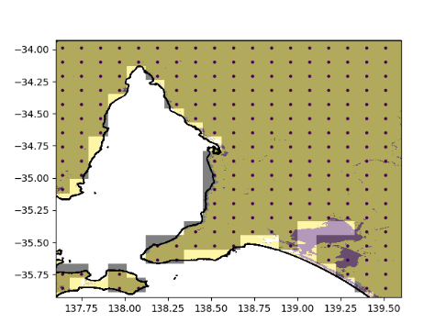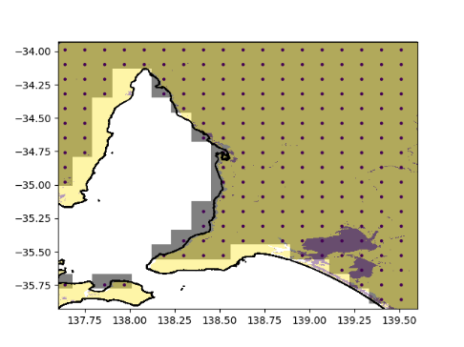

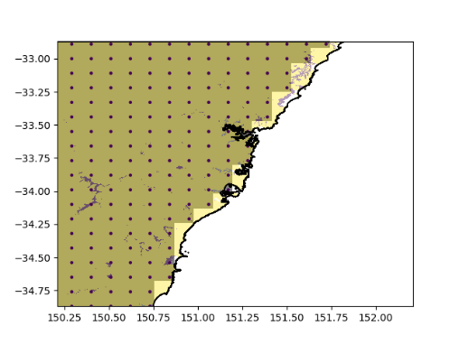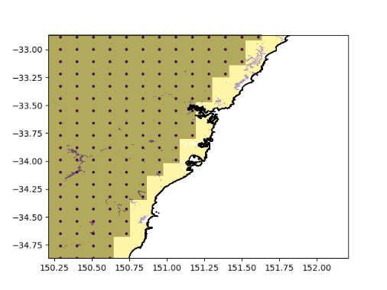

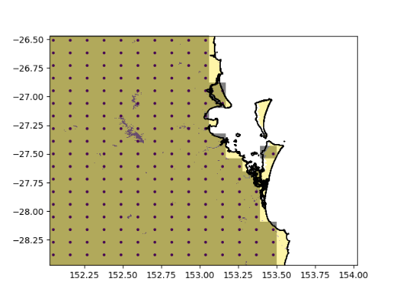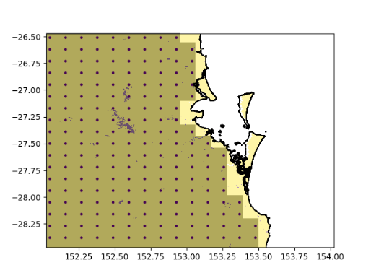

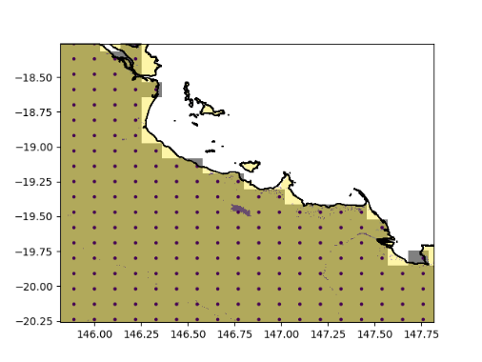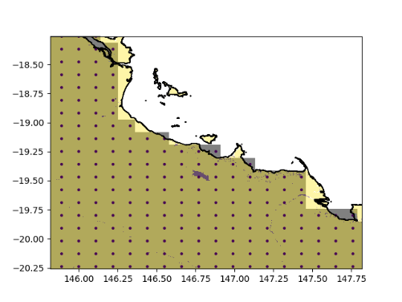

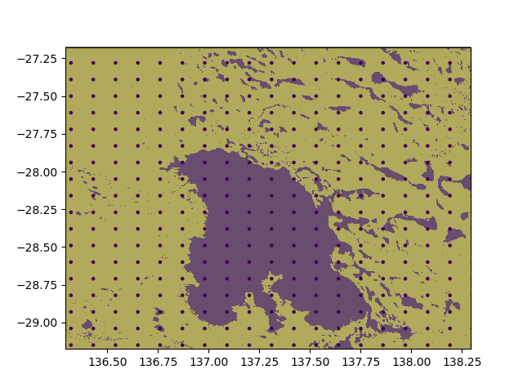

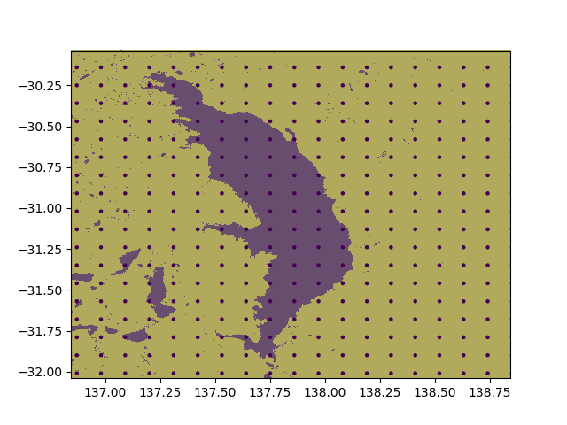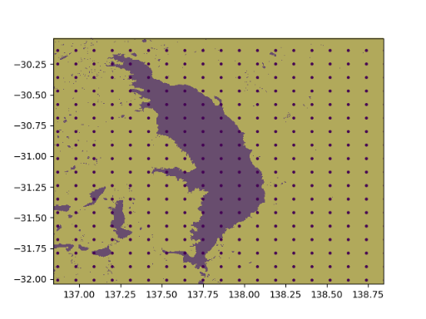

## GL9 and NS land ancillary

According to [GADocumentation/GAAncils/GeneratingAncils/GA8.0 – Global Model Evaluation and Development (metoffice.gov.uk)](https://code.metoffice.gov.uk/trac/gmed/wiki/GADocumentation/GAAncils/GeneratingAncils/GA8.0) and inspection of the [u-bs220](https://code.metoffice.gov.uk/trac/roses-u/intertrac/browser%3Ab/s/2/2/0/trunk), GL9 uses

* IGBP-based land sea mask
* CCI (v3) to derive vegetation fraction (qrparm.veg.frac) on the IGBP land sea mask. This is based on using ${ANCIL_MASTER}/vegetation/cover/cci/v3/vegetation_fraction.nc and ${ANCIL_DATA}/transforms/cci2jules_gl9.json and ${ANCIL_MASTER}/vegetation/cover/cci/v1/c4_percent_1d.asc
* MODIS 4km v2 for LAI, map onto CCI vegfrac ancillary
* Simard Pinto 3DGlobalVeg data for tree PFTs canopy height. The canopy heights other PFTs are derived using canopy_height = height_factor * LAI^2/3. So this uses MODIS LAI as input as well. This described in [#209 (Improved tree heights ancillary) – Global Model Evaluation and Development (metoffice.gov.uk)](https://code.metoffice.gov.uk/trac/gmed/ticket/209)

The GL9 land ancillary changes are accompanied by some science changes described in, [#409 (Surface drag and energy balance package for GL9) – Global Model Evaluation and Development (metoffice.gov.uk)](https://code.metoffice.gov.uk/trac/gmed/ticket/409)

There is some consistency between canopy height and LAI. And changes in canopy, bare soil, shrub, and C4/3 associated with science changes, e.g.

* This part of the package requires a code change to enable the roughness length for each PFT to be specified in the namelist, rather than the parameter that relates the roughness length to the canopy height.
* The distribution of diffuse radiation through the vegetation canopy is updated by setting can_rad_mod=6 (rather than 4).
* the ratio of the roughness length for temperature relative to momentum for bare soil is changed to: 0.2 (from 2.0e-2)

The Nested Suite u-ci305 is able to use, using the ants_vegfrac app

* CCI to derive vegetation fraction (qrparm.veg.frac)
* CCI to derive land sea mask

(based on using ${ANTS_PREPROC_DATA_PATH}/vegetation_fraction.ao996.r73298.nc and ${ANTS_PREPROC_DATA_PATH}/cci2jules.ao996.r73298.json)

I have modified the suite u-ch954 to create,

* Either IGBP-based land sea mask (GA7) or CCI-based land sea mask (based on Nested Suite) – using rose-suite.conf CCI_MASK=false or true. The ancillary are created as land_sea_mask/igbp/qrparm.mask or land_sea_mask/cci/qrparm.mask
* IGBP vegetation fraction ancillary (GA7) on the chosen land-sea mask: vegetation/fractions_igbp/qrparm.veg.frac
* CCI vegetation fraction ancillary (based on Nested Suite) on the chosen land-sea mask: vegetation/fractions_cci-ns/qrparm.veg.frac
* CCI vegetation fraction ancillary (based on GL9) on the chosen land-sea mask: vegetation/fractions_cci-gl9/qrparm.veg.frac . This is triggered using rose-suite.cnf GL9=true.
* GA7 vegetation func (LAI, canopy height) ancillary on chosen land-sea mask: vegetation/func_type_modis/qrparm.veg.func
* GL9 Simard lidar-based vegetation func ancillary on chosen land-sea mask: vegetation/func_type_simard/qrparm.veg.func. This is triggered using rose-suite.cnf GL9=true.
* **TOPMODEL hydro ancillary is defined on chosen vegetation fraction ancillary (using rose-suite.conf VEGFRAC=cci-gl9, igbp, cci-ns)**

18 Nov 2021: Xiao and Imtiaz have examined the PS45/G4 in APS4 trial. Xiao looked at screen temperature difference between PS45 and G3; PS45 appears warmer daytime temperature (up to 20K at some places) than G3. Obspy yet to run yet. Imtiaz looked at APS4 LST.

MO see degradation of T2m in their global trials. Offline JULES testing shows GL9 significantly warmer over Australia.

**Difference in qrparm.veg.frac produced by GL9 (file1) and NS (file2)?**

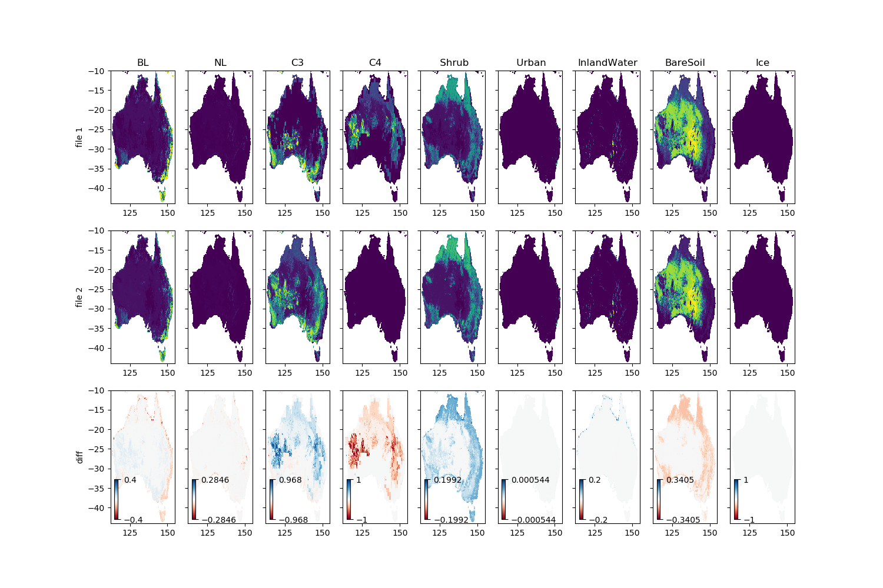

GL9 vegfrac ancillary was created in two steps: (1) create a temporary vegfrac from CCI using the same method as NS but with different source data. GL9's source data has higher bare soil and lower shrub cover, than NS. (2) A post-processing step to add C4 (at the expense of C3) using data from ${ANCIL_MASTER}/vegetation/cover/cci/v1/c4_percent_1d.asc.

This explains the differences seen in bare soil, shrub, C3 and C4.

Imtiaz thinks that G3 underdoes temperature, but G4 might have overdone it, due to the increased bare soil fraction coming from the CCI.

**Difference in qrparm.veg.frac produced by GL9 (file1) and from IGBP (i.e. GAL7) file2?**

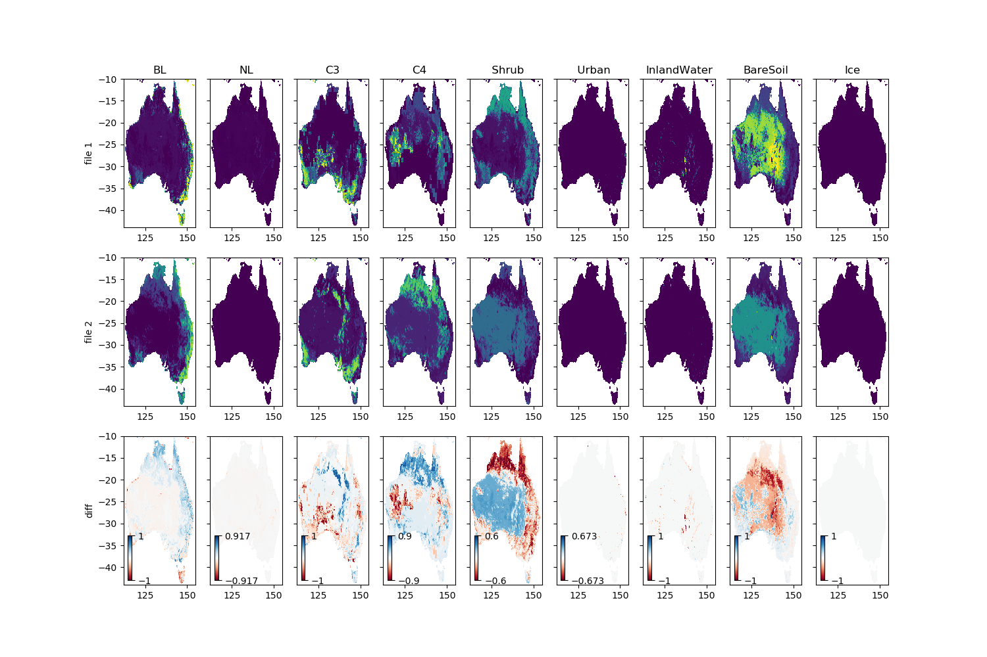

This is similar to the comparison made in [ticket/391/TicketSensTests – Global Model Evaluation and Development (metoffice.gov.uk)](https://code.metoffice.gov.uk/trac/gmed/wiki/ticket/391/TicketSensTests)

GL9 has

* Salt lakes as inland water bodies, particularly over SA. IGBP treats them as Bare Soil.
* Much higher fraction of bare soil over Australian interior
* Much higher fraction of shrub in tropics and eastern regions, while IGBP has higher C4 fractions over the tropics and BL over tropics and eastern regions.

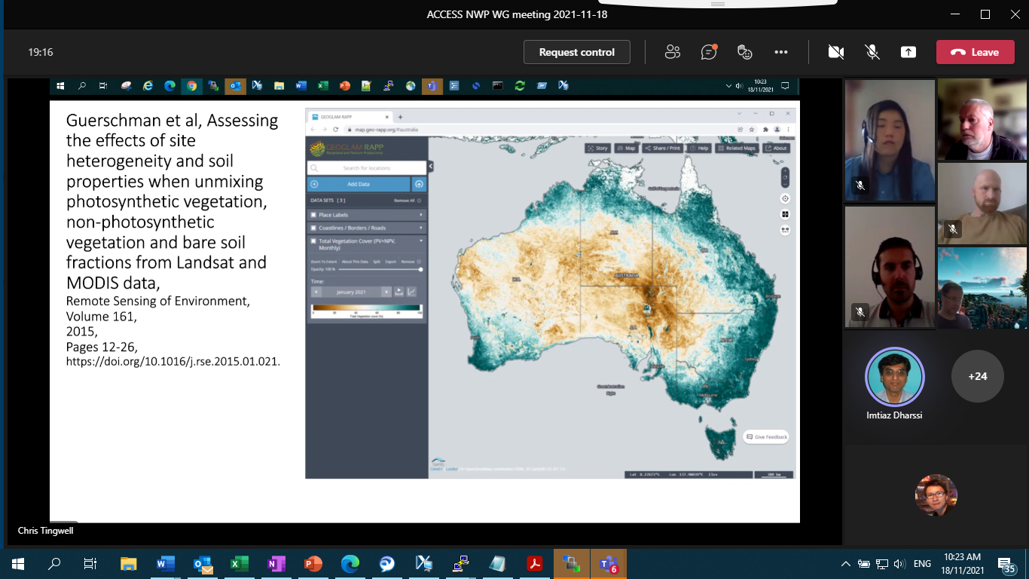

**Difference in LAI in qrparm.veg.func produced by GL9 (file1) and from IGBP (i.e. GAL7) file2?**

* Higher LAI for BL.
* Lower LAI for C3 and higher LAI for C4 over tropics and extratropics.
* Higher LAI for Shrub over tropics and Southeast.
* GL9 LAI looks noisy and has spotty high values of LAI. To confirm this, zooming in and comparing with the n1280e/orc025 ancillary (/g/data/access/projects/access/umdir/ancil/atmos/n1280e/orca025//vegetation/func_type_modis/v1/qrparm.veg.func, first row) and the one I created with u-ch954 (second row):

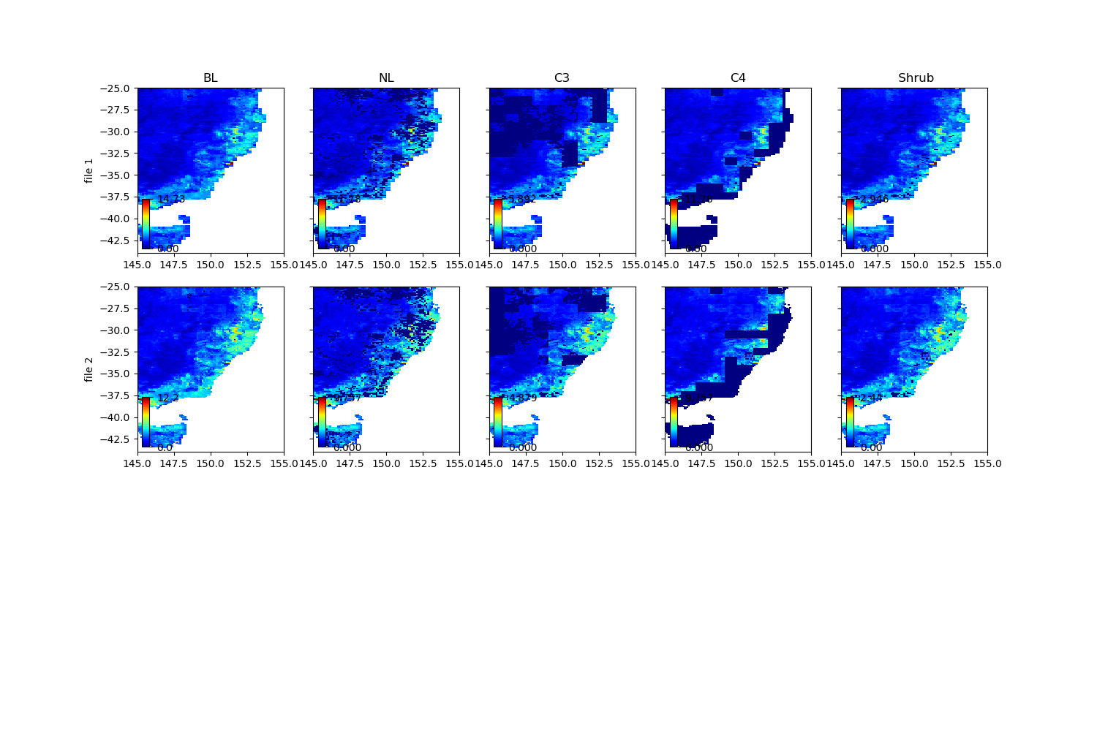

**Difference in CANOPY HEIGHT in qrparm.veg.func produced by GL9 (file1) and from IGBP (i.e. GAL7) file2?**

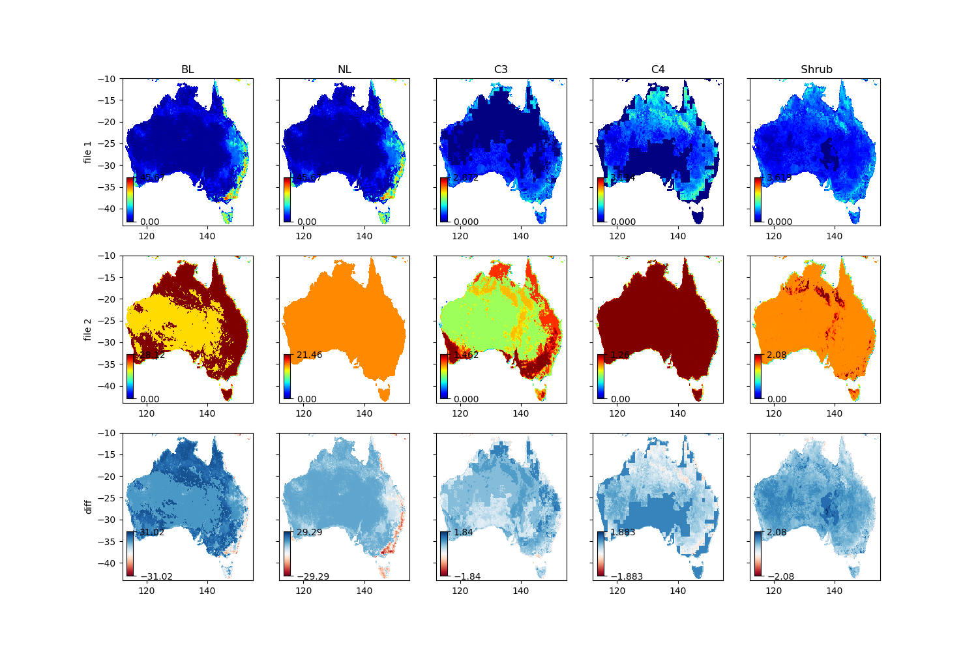

* Note that in GL9, canopy_height = height_factor * LAI^2/3
* The GAL7 ancillary is naturally very unrealistic, and GL9 is more realistic to represent spatial variability in the canopy height over SE and Tasmania.

**Difference in CANOPY HEIGHT in qrparm.veg.func produced by using Dharssi' ancil_simardCanHT.py script (file1) and from GL9 (file2)?**

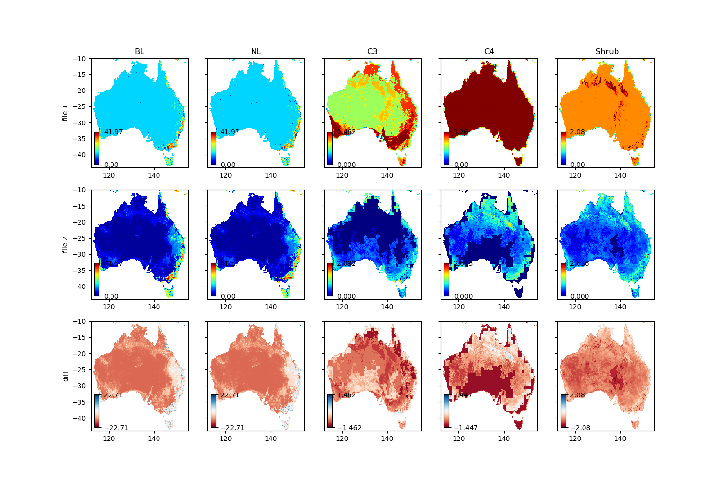

* Ancil_simardCanHT only updates the canopy height for BL and NL.
* The canopy height has a constant of around 10m, compared to GL9 which has 0 m.

## Spurious land points in the southern edge of the domain

The land sea mask for the 0.30deg ensemble grid, /g/data/du7/barra2/data/ancil_ens/land_sea_mask/igbp/qrparm.mask

The mask was created by CAP using IGBP:

This problem was described but not fixed in, [#391 (Corrupted land-sea mask in regional domains) – ANCIL (metoffice.gov.uk)](https://code.metoffice.gov.uk/trac/ancil/ticket/391)

We can use

&DATAC FIELD_NO=1, POINT_NO=58051, DATA_NEW=.FALSE. /

:

&DATAC FIELD_NO=1, POINT_NO=58320, DATA_NEW=.FALSE. /

This is essentially (nlat-1)*nlon+1, +2, …, +nlon.

To deal with this problem - set up a new opt conf to ingest the namelist to flip the spurious land points to sea point.

*However, given the progress described in Section 7 and 8 to create land mask from CCI data using ANTS, this problem with CAP is avoided.*

The CCI-based land mask produced by ANTS for the two BARRA-RE2 domains are (0.22deg, left) and (0.33deg, right):

## Ancillary for the BARRA-R2/RE2 and BARPA-R trial

Given that we are not ready to upgrade to PS45 or GAL9 configuration, we will use GAL7 ancillary, but with the changes noted earlier,

* Modified the ancilOrog to use $ANCIL_MASTER/orography/GLOBE30/v1/GLOBE30_aus.orog
* Modified the ancilOrog to remove isolated negative orography points, using l_remove_neg_pt=.true.
* more accurate land sea mask from CCI – see **Section 7 and 8**
* Imtiaz and Peter advised to use canopy tree height for NL and BL in vegfunc ancillary as the bare minimum, and continue to use canopy height for other PFTs. This is created as **vegetation/func_type_merge/qrparm.veg.func**

As the land cover ancillary (and LAI, as they need to be consistent), this needs discussion with Chris Rudiger.

There is also discussion possible ancillary options for land cover (and LAI) and canopy height:

|  |  |  |
| --- | --- | --- |
| **Options** | **Ancillary** | **Comments** |
| Baseline | Use canopy tree height for BL (and NL) only. Continue to use GL7 canopy height for C3, C4, and Shrubs.  LAI and land cover ancillary unchanged (LAI is created from vegfrac/land cover) | Imtiaz and Peter noted this is a justifiable, as tree height is more realistic and does not require science changes to GAL7 configuration. |
| Candidate | Use canopy tree height for all PFTs  LAI and land cover ancillary unchanged (LAI is created from vegfrac/land cover) | Imtiaz thinks this is OK, but requires testing. A trial can be used to assess the impact of this. |
| Ambitious upgrade | Use GL9 ancillary for land cover and vegfunc (LAI, canopy height) ancillary. | This requires entire upgrade of the system to GAL9 (and PS45 for BARRA2). This bases on the evaluation of APS4/PS45 trial that has just begun and can take a few months to complete. We are running offline JULES to initialise soil moisture for BARRA2, and this can take 1-2 months to run. We plan to start the production of BARRA2 in April/May, so we need to decide on land cover ancillary for offline JULES runs, latest by end February (ideally earlier)  Imtiaz to consult Adrian. Peter organise a meeting with Met Office is more likely to get a response. |
| Stretch | Use canopy tree height for BL (and NL).  GA-derived land cover and associated LAI.  Canopy tree height for C3, C4, Shrub will come from LAI (as per GL9). | Chris R team will start work on translating GA land cover to JULES land cover in January 2022. He may also prefer to use different methods to derive LAI. This may take few months, and unlikely in time for offline JULES runs.  It is unclear whether science changes associated with the above ancillary change are needed for either GAL7 or GAL9 configurations.  Imtiaz to consult Adrian. Peter organise a meeting with Met Office is more likely to get a response. |

~~And remain to use IGBP-based vegetation fraction, constant heights for each PFT, and GAL7 LAI.~~

For BARRA2, the generated ancillary are,

* /g/data/hd50/barra2/data/ancil_barra-r2
* /g/data/hd50/barra2/data/ancil_barra-re2_022
* /g/data/hd50/barra2/data/ancil_barra-re2_033

And for BARPA,

* /g/data/tp28/dev/barpa/ancils/barpa-r

The difference between BARPA-R and BARRA-R2 are that BARRA-R2 uses L70/80km vertical levels and 0.11deg grid while BARPA-R uses L63/41km vertical levels and 0.1545deg grid.

**Currently, no smoothing of orography over north of 10S.**

## 3D ancillary generation for NorESM2-MM

Harvey has noted

*As can be seen from* [*CMIP6_availability (1).xlsx*](https://bom365-my.sharepoint.com/:x:/g/personal/harvey_ye_bom_gov_au/EWXBNWK73FhKt5dWE86D5e8BNzn63KejUbjgqswShWm9zQ?e=7i6QcQ&wdLOR=cC7CDA1DA-FD36-42D3-9E5F-BEDE222F3B23)*, the NorESM2 models have the lowest top of all in set-of-12. For BARPA's domain, extrapolation will not happen with a model top of 34 km. With the safeguarding of the thresholding of the minimum pressure, slight extrapolation will no longer be an issue. Therefore, my recommended vertlev file for the 'lower-top' version of BARPA is vertlevs_L60_50t_10s_32km. On the other hand, ACCESS-ESM1-5 has a top of 39 km. Therefore, the recommended 'higher-top' version of BARPA uses vertlevs_L63_50t_13s_39km.*

Therefore we need to create aerosol_clims, aerosols, ozone/CMIP6, ozone/sparc specifically for the revised/non-standard vertical 60-level namelist: *vertlevs_L60_50t_10s_32km*

I adopted script from ants: /g/data/access/projects/access/apps/ants/0.14.0/bin/ancil_general_regrid.py:

and made significant changes to make it work for 365day calendar and to perform vertical interpolation.

The script is,

<https://code.metoffice.gov.uk/svn/utils/access/branches/dev/Share/barpa_shared_dev/bin/ancil/ancil_general_regrid.py>

The command is, ./ancil_general_regrid.py $input --target-grid vertlevs_L60_50t_10s_32km /g/data/tp28/dev/barpa/ancils/barpa-r/land_sea_mask/cci/qrparm.mask --output $out --calendar 360day

The created climatological ancillaries are,

/g/data/tp28/dev/barpa/ancils/barpa-r/aerosol_clims/ga6_antie/qrclim.*60

/g/data/tp28/dev/barpa/ancils/barpa-r/ozone/sparc/1994-2005/qrclim.ozone_L60_O60